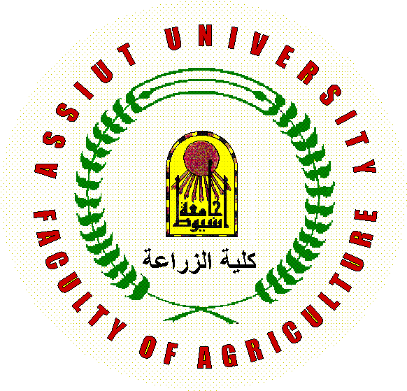


CURRICULUM VITA, PhD

(2015)

CURRICULUM VITA

الاسم: ريهام محمد محمد علي عبدالله
الوظيفة: مدرس مساعد بقسم الخضر
تاريخ الميلاد: 18-2-1983
الحالة الاجتماعية: متزوجة
العنوان: كلية الزراعة – جامعة اسيوط
تليفون: عمل- 088-2142888
2331348-فاكس- 0020-088
منزل- 088-2320290
محمول- 01005085089

E-mail: mmalyabdalla@yahoo.com

Education:
Degree | Year | Institution | Country
B.Sc. | 2004 | Assiut University | Egypt
M. Sc. | 2009 | Assiut University | Egypt
Ph.D. | - | Pennsylvania Universite | USA

Master Thesis Title:
Physiological studies on different genotypes of strawberries
Ph.D. Thesis Title:

Employment

Years | Institution |  | Position
2004 to 2008 | Faculty of Agriculture, Assiut University, Egypt |  | Demonstrator
2009 till now | Faculty of Agriculture, Assiut University, Egypt |  | Assistant lecture

List of publication
Reham M. Abdalla, M.H. Aboul-Nasr, N.M. Kandil, S.Z. Agamy, Kaatrina Mouho, Timo Hytonen, Paula Elomaa (2009). The effect of photoperiod and gibberellic acid on strawberry F. vesca var. semperflorens (Baron solemacher cultivar). Assiut Journal of Agricultural Sciences, 40:97-120.

